eWEEK OpenHack IV – Oracle Solution Information
Oracle 9i R2 RDBMS and Oracle 9iAS R2
John Abel, Oracle UK Consulting (john.abel@oracle.com)
Ian Bryson, Oracle UK Consulting (ian.bryson@oracle.com)
Project Overview

eWeek have requested Oracle Corporation to participate in OpenHack which is a competition to find if a product is “breakable”. Oracle Corporation have taken an eWeek application and migrated to an Oracle 9iAS R2 J2EE environment, using only Oracle components (e.g. Oracle 9i RDBMS R2 and Oracle 9iAS R2). Some changes have been made to make the application even more secure and resilient to penetration attacks. The following are the areas covered by the white paper:

- Database changes (migrate from IBM DB2 to Oracle 9i RDBMS).
- Application changes (migrate IBM Specific application to Oracle 9iAS J2EE application).
- Document hardware configuration recommended for OpenHack.
- Document software configuration changes.
- Identify other enhancements that have been made to the application to enhance the security.

Audience

The following information should be used in conjunction with Supplier specific install and configuration document. It is assumed that the person(s) using the following notes is fully aware of the following products:
- Red Hat Advanced Server 2.1.
- Oracle 9iAS Release 2.
- Oracle 9i RDBMS Release 2.

Figure 1 explains the key components to the solution; all components are explained in more detail within this document.

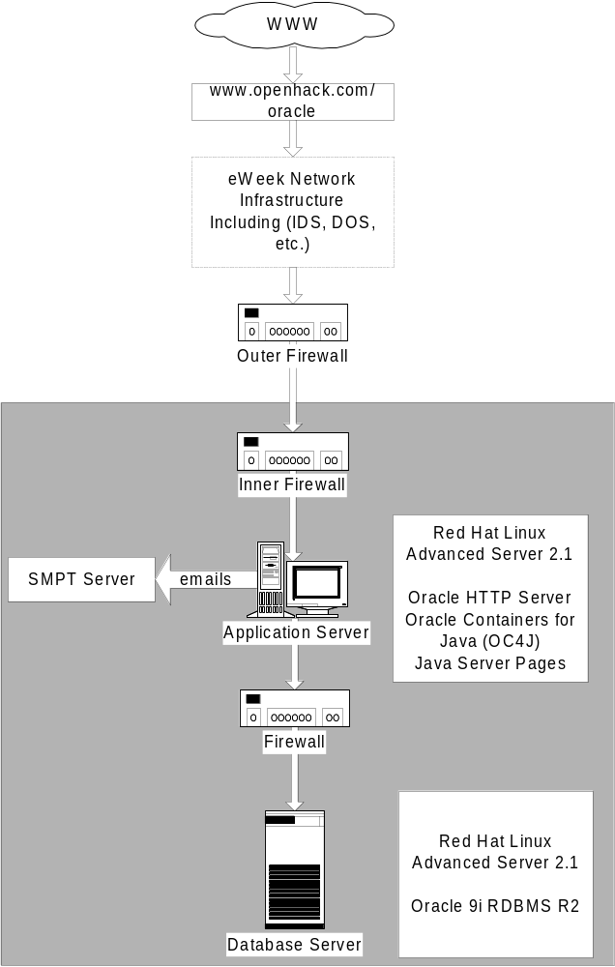
Figure 1

Database Changes

The following changes have been made to the eWeek scripts to migrate them from IBM DB2 to Oracle 9i RDBMS. In addition, some changes have been added to enhance the script.
Script name : create_awards_db_20020327 (DB2).sql (new name create.sql)

DB2 Script | Oracle Script “Change”
CONNECT TO AWARDS | The following was added so the script is run as SYSTEM/MANAGER.  CONNECT SYSTEM/MANAGER
Add some Oracle Specifics to create the users. | The following command will drop the users if they exist already  DROP USER EXADMIN CASCADE;  DROP USER JUDGE CASCADE;  DROP USER WEBUSER CASCADE;  Grant connect and resource roles to the three core users. Each user has a default password that is changed later.  GRANT CREATE SESSION,  CREATE SEQUENCE,  CREATE SYNONYM,  CREATE PROCEDURE,  CREATE TABLE,  CREATE TRIGGER  TO EXADMIN IDENTIFIED BY EXADMIN;  GRANT CREATE SESSION,  CREATE SEQUENCE,  CREATE SYNONYM,  CREATE VIEW  TO JUDGE IDENTIFIED BY JUDGE;  GRANT CREATE SESSION,  CREATE SEQUENCE,  CREATE SYNONYM,  CREATE VIEW  TO WEBUSER IDENTIFIED BY WEBUSER;  ALTER USER EXADMIN QUOTA UNLIMITED ON USERS;  Set the users default Tablespace and the sort Tablespace for temporary segments.  ALTER USER EXADMIN DEFAULT TABLESPACE USERS TEMPORARY TABLESPACE TEMP;  ALTER USER JUDGE DEFAULT TABLESPACE USERS TEMPORARY TABLESPACE TEMP;  ALTER USER WEBUSER DEFAULT TABLESPACE USERS TEMPORARY TABLESPACE TEMP;  Connect to base owner of the objects.  CONNECT EXADMIN/EXADMIN
All VARCHAR data types | Changed from VARCHAR to VARCHAR2 that is Oracle character variable data type.
IN “USERSPACE1”; | Removed the reference to the Tablespace and allowed objects to be created in user default Tablespace.
GENERATED ALWAYS AS IDENTITY (START WITH +1, INCREMENT BY +1 CHAR 20) | Changed from IBM-specific syntax to equivalent Oracle syntax. Used the combination of the following to give the same effect:  - Create a sequence number;  CREATE SEQUENCE RANKINGS_SEQ;  CREATE SEQUENCE COMPANIES_SEQ;  CREATE SEQUENCE CATEGORIES_SEQ;  CREATE SEQUENCE PRODUCTS_SEQ;  - Created four triggers with the following construct;  CREATE OR REPLACE TRIGGER PRE_RANKINGS  BEFORE INSERT ON RANKINGS FOR EACH ROW  BEGIN  SELECT <sequence number>  INTO :new.ID  FROM DUAL;  END;  /
All INTEGER data types | Changed all INTEGER data types to Oracle NUMBER data types.
All “Schema owner”. “Object name” | Removed the “Schema owner”. “Object name” and replaced with just object name
All TIMESTAMP data types | Changed all TIMESTAMP data types to Oracle DATE data types, just incase dates are stored in fields.
All Constraints with the following construct.  ON DELETE NO ACTION  ON UPDATE NO ACTION | Removed the ON DELETE… and ON UPDATE… from constraints. Oracle syntax is different for ON DELETE / ON UPDATE.
All GRANT permissions | Changed all grant permissions from DB2 specific to Oracle specific.

The following script inserts the data into the static tables.
Script name: awards_db_base_data.sql

DB2 Script | Oracle Script “Change”
Connect to awards user exadmin using yoda7958 | Changed to connect exadmin/exadmin that is Oracle code format.
None | Added the following DML statements to the script, so it can be re-run when used for a second time:  delete from judges;  delete from creditcards;  delete from categories;  delete from states;
All INSERT Statements | Added column definitions to INSERT Statements, the following was a before and after change.  Before  INSERT INTO EMP VALUES (…);  After  INSERT INTO EMP (…) VALUES (…);
DEFAULT Clause | Removed DEFAULT clause allowed the database trigger to insert column

Application Code Changes

The following code changes where required to get the OpenHack application to run on Oracle 9iAS and Oracle 9i R2 RDBMS. There are 3 main reasons for changing the code.
- Security enhancements - required for extra hardening.
- SQL differences – differences between DB2 and Oracle.
- Application server differences – where there were slight differences in the application servers.

JSP File | Changes required | Reason for change | Lines changed
/include/open_db.jsp | JDBC connection creation changed to use connection pooling. This will prevent a possible DOS problem, by restricting the number of JDBC database connections. | Security enhancement | 12, 18-20, 29-38
/include/catch.inc | Actual error message removed so no useful errors are returned to the users (e.g. machine name, used ports, etc). | Security enhancement | 21, 24
/include/functions.jsp | Included new method SMTPize() to prevent scripting attacks in emails. | Security enhancement | 157 – 189
/include/functions.jsp | Change name of SMTP server | Different mailserver used for the production site | 233
accountcreateedit.jsp | DB2 TIMESTAMP converted to Oracle SYSDATE | SQL difference | 226, 240
accountcreateedit.jsp | SMTPize() all email parameters | Security enhancement | 261, 267, 268
accountcreateedit.jsp | Added call to encryption PL/SQL package for site username and password | Security enhancement | 218
accountdetailsmail.jsp | SMTPize() all email parameters | Security enhancement | 96, 102, 103
companycreateedit.jsp | DB2 TIMESTAMP converted to Oracle SYSDATE | SQL difference | 507, 509, 557, 560, 563, 582, 614
companycreateedit.jsp | DB2 IDENTITY_VAL_LOCAL() changed to Oracle nextval | SQL difference | 513
companycreateedit.jsp | Some Web Servers print "" for a null value where 0C4J prints "null" so a check is required for null values | Application server difference | 471-482
companycreateedit.jsp | SMTPize() all email parameters | Security enhancement | 656, 666, 667, 672, 673, 699 700,
companycreateedit.jsp | Added call to encryption PL/SQL package for credit card number and expiry date | Security enhancement | 535, 536, 594, 595
companycreateedit.jsp | Decrypt credit card number and expiry date | Security enhancement | 466
entryconfirm.jsp | DB2 TIMESTAMP converted to Oracle SYSDATE | SQL difference | 321, 362,
entryconfirm.jsp | SMTPize() all email parameters | Security enhancement | 385 – 430
login.jsp | Added encrypt to users password | Security enhancement | 50
passwordchange.jsp | Added encrypt PL/SQL function call to the users password | Security enhancement | 93, 100
passwordchange.jsp | DB2 TIMESTAMP converted to Oracle SYSDATE | Database difference | 99

Deploying the Application

This section shows how to deploy the OpenHack application to 9iAS. The deployment of the application is done by creating a new OC4J instance (or component) which will host the application. The actual application is packaged as an ear file which can then be deployed using the dcmctl command which comes with 9iAS.
Create new component
Type the following to create a new OC4J component to run the application.

$ dcmctl createComponent -ct oc4j -co openhack –v

This will create a new openhack component. Check that this has been successful by running the following command:

$ dcmctl getState –v

This will should show that an new openhack OC4J instance has been created.

Deploying the application
To deploy the application copy the openhack.ear file into your 9iAS $ORACLE_HOME directory. Now type the following at the command line:
$ dcmctl deployApplication -file /u01/app/oracle/product/IAS2.0/openhackapp.ear -a openhack -co openhack –v
The application is now deployed.

Add database connection
To add the database connect string for the application go to the $ORACLE_HOME/j2ee/openhack/config/data-sources.xml file and add the following with your server specific URL.

<data-source class="oracle.jdbc.pool.OracleDataSource"
name="OracleDS"
location="jdbc/OpenHackDS"
xa-location="jdbc/xa/OracleXADS"
ejb-location="jdbc/OracleDS"
connection-driver="oracle.jdbc.driver.OracleDriver" url="jdbc:oracle:thin:@machine.oracle.com:1521:HACK_SID"
inactivity-timeout="30”
/>

Add static HTML pages
Go to the $ORACLE_HOME/Apache/Apache/htdocs directory and remove all of the files and directories by typing the following:

$ rm –rf *
This will remove all the demo files. Now copy the index and error pages to this directory:

$ cp $ORACLE_HOME/j2ee/openhack/applications/openhack/openhackapp/index.html $ORACLE_HOME/Apache/Apache/htdocs/index.html

$ cp $ORACLE_HOME/j2ee/openhack/applications/openhack/openhackapp/error.html $ORACLE_HOME/Apache/Apache/htdocs/error.html

This will provide the initial first page of the application and the standard error page. The URL’s in the index.html page will need to be changed so that the correct machine name is added.

Oracle 9iAS R2 Configuration Changes

This section shows the changes that need to be made to the default 9iAS installation to provide better application security.

httpd.conf
The following changes where made to the httpd.conf file to provide better application security. This file can be found in the 9iAS $ORACLE_HOME/Apache/Apache/conf directory.

Remove the Perl, CGI and FastCGI Apache mods so no Perl or CGI scripts can be run.

LoadModule perl_module libexec/libperl.so
LoadModule fastcgi_module libexec/mod_fastcgi.so
LoadModule cgi_module libexec/mod_cgi.so

Change ServerSignature to off and add ServerTokens to Prod. This will prevent any machine information being leaked to HTTP requests:

ServerSignature Off
ServerTokens Prod

Change mod_autoindex to the following:

<IfModule mod_autoindex.c>
IndexIgnore *
</IfModule>

The mod_ossl Module tag will need to be change so that SSL is configured with the Wallet Manager. An example of this can be seen below. The directory paths must be changed to the correct ones for the Apache server.

<IfModule mod_ossl.c>
SSLLog /u01/app/oracle/product/IAS2.0/Apache/Apache/logs/ssl_engine_log
SSLLogLevel warn

<VirtualHost _default_:443>
ServerName servername.eweek.com
ServerAdmin a@b.c
ErrorLog /u01/app/oracle/product/IAS2.0/Apache/Apache/logs/error_log
TransferLog /u01/app/oracle/product/IAS2.0/Apache/Apache/logs/access_log
Port 443
SSLEngine on
SSLCipherSuite ALL:+HIGH:!LOW:!NULL
SSLWalletPassword xxxxxxx
SSLWallet file:/u01/app/oracle/product/IAS2.0/Apache/Apache/conf/ssl.wlt/default
</VirtualHost>
Listen 443
</IfModule>

Remove the mod_alias, mod_perl and mod_fastcgi module tags and their contents from this file.

To prevent scripting attacks the following need to be entered:

<LocationMatch "\%">
Order allow,deny
Deny from all
</LocationMatch>

<Files ~ "\%">
Order allow,deny
Deny from all
</Files>

<LocationMatch /[Ss][Cc][Rr][Ii][Pp][Tt]>
Order allow,deny
Deny from all
</LocationMatch>

<Location ~"^/_pages">
Order deny,allow
Deny from all
</Location>

<Files ~"^\globals.ja">
Order deny,allow
Deny from all
</Files>

Redirect all types of errors to a standard error page by adding the following:

ErrorDocument 500 /error.html
ErrorDocument 404 /error.html
ErrorDocument 401 /error.html
ErrorDocument 400 /error.html
ErrorDocument 403 /error.html

Ensure that the user who is running the Apache process is set to a user with few privileges. So change the User and Group directives to do this, for example:

User nobody
Group nobody

Remove the link to the oracle_apache.conf file.

Also add the following to ensure that the access and resource configurations are always null.

AccessConfig /dev/null
ResourceConfig /dev/null

mod_oc4j.conf
The default mount points were removed from this file. So the file will only have the following mount points in it. This file can be found in the 9iAS $ORACLE_HOME/Apache/Apache/conf directory.

Oc4jMount /openhack openhack
Oc4jMount /openhack/* openhack

These changes remove all possibility of the other default OC4J instances being called via a HTTP request.

global-web-application.xml
This file can be found in the $ORACLE_HOME/j2ee/OpenHack/config directory. Comment out all of the unnecessary servlet handlers. So comment from the following lines:

<!--
<servlet>
<servlet-name>rmi</servlet-name>
<servlet-class>com.evermind.server.rmi.RMIHttpTunnelServlet</servlet-class>
</servlet>
. . . .
. . . .
<servlet>
<servlet-name>php</servlet-name>
<servlet-class>com.evermind.server.http.CGIServlet</servlet-class>
<init-param>
<param-name>interpreter</param-name>
<param-value>php</param-value>
</init-param>
</servlet>
- - >
Now add the following lines into the JSP servlet handler. This ensures that the JSP’s cannot be recompiled once run.
<servlet>
<servlet-name>jsp</servlet-name>
<servlet-class>oracle.jsp.runtimev2.JspServlet</servlet-class>
<init-param>
<param-name>debug_mode</param-name>
<param-value>false</param-value>
<init-param>
. . .

Managing The Application

Starting the application
To start the application up type in the following:
$ opmnctl start
This will start the opmn process that monitors the status of other 9iAS processes for high availability.
Then:
$dcmctl start –ct oc4j –co openhack –v
Which start the OC4J openhack instance. Then do:
$dmctl start –ct ohs -v
Which starts the Oracle HTTP server. The application should now be started.
Stopping the application
To stop the application type in the following:
$ dcmctl stop –ct oc4j –co openhack –v
$ dcmctl stop –ct ohs
$ opmnctl stopall
Hardware and Operating System

Figure 2 has all the major hardware components for the OpenHack solution. The following sections concentrates on Application / Database servers.

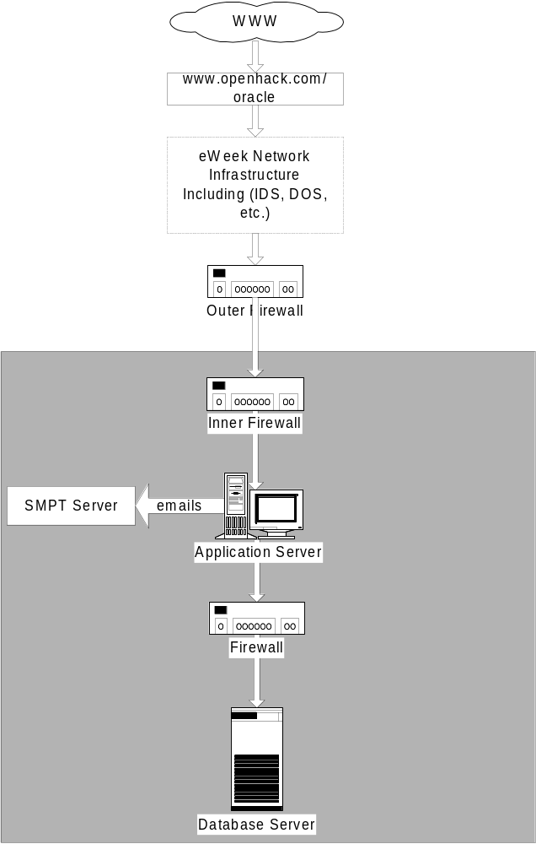
Figure 2
Firewall Rule sets
The following are the firewall rule sets that have been setup for the eWeek application:

- Between Outer and Inner firewalls it is required to have a NAT Proxy configured, the NAT will perform IP Name Translation.
- Only port 80 and 443 should be configured on outer firewalls
- Allow only port 22 for SSH, 443 for SSL, 1521 for database connections and 80 for HTTP
- Allow only port 22 for SSH and port 1521 for database connections.

Application Server Configuration
The following is the hardware configuration for the application server, based on LINUX. If this is unknown then view the file /var/log/dmesg which contains the hardware information for the server.
- Memory; 2GB of main memory
- CPU; 1 or 2 CPU’s with a speed of 1Ghz+.
- Disk Requirement; 3GB of usable disk space

The following is method used to harden the application server operating system. All the methods given below have successfully been used on a Dell PowerEdge machine.
- Install Red Hat Advanced Server 2.1; perform a basic install (install without software firewall option).
- Once the Red Hat base install is complete then install Bastille 1.3.0 for Red Hat 7.2 (Bastille can be downloaded from http://www.bastille-linux.org). When installing the package, answer no to the prompt asking you “Do you want to continue with the Bastille configuration”.
- Appendix A has the Bastille configuration file which is copied to /etc/Bastille (backup the existing file) and run /usr/sbin/BastilleBackEnd.
- The following post install steps need to be completed:
- Make sure that sendmail is disabled from all startup scripts and the process is stopped. The following change could be made to the startup script (/etc/rc.d/init.d/sendmail):
- Added exit 0 at the beginning of the file.
- All the configuration files in the directory (/etc/xinetd.d) have “disable=yes” set.
- Set-up host restriction for SSH connections, this is done within hosts.allow file. Add the host names for allowed connection servers.
- Disable all non-required process daemons (e.g. telnet).
- The following post install instructions need to be followed before Oracle 9iAS R2 can be installed:
- Install the following packages:
- binutils-2.11.90.0.8-13 "http://metalink.oracle.com", Patch #2414946)
- pdksh-5.2.14-13 (any package to install KSH will do)
- soft link /sbin/fuser to /bin/fuser (use ln –s … …)
- set $PATH to look initially in /usr/bin
- Validate that no new security alerts have been raised against Red Hat Advanced Server 2.1; access http://www.redhat.com/apps/support/errata/ URL for more information.

Setting the Oracle 9iAS R2 environment Variables
The commands below can be used as an example for setting these variables. Change the path values as appropriate.

ORACLE_HOME=<install directory for base product>; export ORACLE_HOME
TNS_ADMIN=$ORACLE_HOME/network/admin; export TNS_ADMIN
LD_LIBRARY_PATH=/lib:$ORACLE_HOME/lib:$ORACLE_HOME/network/lib:/usr/lib; export LD_LIBRARY_PATH
JAVA_HOME=$ORACLE_HOME/jdk; export JAVA_HOME
PATH=$PATH:$ORACLE_HOME/jdk/bin:$ORACLE_HOME/bin:$ORACLE_HOME/dcm/bin:$ORACLE_HOME/opmn/bin:$ORACLE_HOME/Apache/Apache/bin; export PATH
TMP=/var/tmp; export TMP

Database Server Configuration
The following is the database server configuration, based on Linux Red Hat Advanced Server 2.1 .
- Memory; 1GB of main memory
- CPU; 1 or 2 CPU’s with a speed of 400Mhz+.
- Disk Requirement; 6GB of usable disk space

The following is method used to harden the database server operating system.
- Install Red Hat Advanced Server 2.1; perform a basic install (install without software firewall option).
- Once the Red Hat base install is complete then install Bastille 1.3.0 for Red Hat 7.2 (Bastille can be downloaded from http://www.bastille-linux.org). When installing the package, answer no to the prompt asking you “Do you want to continue with the Bastille configuration”.
- Appendix A has the Bastille configuration file which is copied to /etc/Bastille (backup the existing file) and run /usr/sbin/BastilleBackEnd.
- The following post install steps need to be completed:
- Make sure that sendmail is disabled from all startup scripts and the process is stopped. The following change could be made to the startup script (/etc/rc.d/init.d/sendmail):
- Added exit 0 at the beginning of the file.
- All the configuration files in the directory (/etc/xinetd.d) have “disable=yes” set.
- Set-up host restriction for SSH connections, this is done within hosts.allow file. Add the host names for allowed connection servers.
- Disable all non-required process daemons (e.g. telnet).
- The following post install instructions need to be followed before Oracle 9iAS R2 can be installed:
- Install the following packages:
- binutils-2.11.90.0.8-13 "http://metalink.oracle.com", Patch #2414946)
- pdksh-5.2.14-13 (any package to install KSH will do)
- soft link /sbin/fuser to /bin/fuser (use ln –s … …)
- set $PATH to look initially in /usr/bin
- Validate that no new security alerts have been raised against Red Hat Advanced Server 2.1; access http://www.redhat.com/apps/support/errata/ URL for more information.

Setting the Oracle RDBMS 9i R2 environment Variables
Firstly, ensure that the following Oracle environment variables are set. The script below can be used as an example for setting these variables. Change the path values as appropriate.

ORACLE_HOME=<install directory for base product>; export ORACLE_HOME
TNS_ADMIN=$ORACLE_HOME/network/admin; export TNS_ADMIN
LD_LIBRARY_PATH=/lib:$ORACLE_HOME/lib:$ORACLE_HOME/network/lib:/usr/lib; export LD_LIBRARY_PATH
PATH=$PATH:$ORACLE_HOME/jdk/bin:$ORACLE_HOME/bin:$ORACLE_HOME/dcm/bin:$ORACLE_HOME/opmn/bin:$ORACLE_HOME/Apache/Apache/bin; export PATH
TMP=/var/tmp; export TMP

Oracle Software Components Required

The following are the Oracle products required for the solution and hardening information:
Oracle 9iAS R2 (Application Server)
The following is the specific install information for Oracle 9iAS R2 for LINUX (Part Number A91825-01)
- Install Oracle 9iAS R2 “Core” components, HTTPD and OC4J.
- Install Security Alerts #36
- Install Security Alerts #37
- Install Security Alerts #41 and review the URL http://otn.oracle.com/deploy/security/alerts.htm
Oracle 9i RDBMS R2 (Database Server)
The following is the specific install information for Oracle 9i RDBMS R2 for Linux (Part Number A99339-01).
- Install Oracle 9i RDBMS “Core” components
- Apply the following Patches/Workarounds
- Install Security Alerts #33 (Database Server)
- Install Security Alerts #38 (Database Server)
- Install Security Alerts #40 (Database Server) and review the URL http://otn.oracle.com/deploy/security/alerts.htm
- Create default database as shipped with the database product.
- Extend the USERS Tablespace (alter tablespace add datafile /<directory>/user02.dbf’ size 200MB).
- The following are the key hardening methods required for the database server:
  - Change all passwords within the database (select username from dba_users), once all the users are selected use (alter user <username> identified by <password>) to change each password.
  - Remove all old binary files from $ORACLE_HOME/bin rm *O, note using “O”, not zero.
  - Change permission on listener files : cd $ORACLE_HOME/bin; chmod o-x lsnrctl, chmod o-x extproc, chmod o-x extproc32.
  - Edit the LISTENER.ORA add TRACE_LEVEL_LISTENER=OFF (or change to OFF) and ADMIN_RESTRICTIONS_LISTENER=ON.
  - Use lsnrctl status on listener and makesure that No SNMP process is running, No EXTPROC process is running and listener has a password.

Other Application Changes
The following PL/SQL was used to encrypt the database objects with secure data (e.g. credit card numbers, etc). The method provided is a DES3 encryption cipher-block-chaining (CBC), using random Hex seeded data elements, derived from /dev/random. The code provided is not the most secure, but just gives another level of security. Once the code is stored on the server, then use the Oracle “Wrap” function to encrypt the code and store the encrypted code in the database and remove the unencrypted PL/SQL.

CREATE OR REPLACE PACKAGE EDPP001_enc AS

FUNCTION encrypt( P_input_value IN VARCHAR2)

RETURN RAW;

END EDPP001_enc;
/

CREATE OR REPLACE PACKAGE BODY EDPP001_enc AS

FUNCTION encrypt( P_input_value IN VARCHAR2)

RETURN RAW

IS

-- Declare variables

v_input_value VARCHAR2(256);
l5 RAW(128);
l3 RAW(128);
l9 RAW(128);
l4 RAW(128);
IV RAW(128);
l1 RAW(128);
l6 RAW(128);
l8 RAW(128);
l2 RAW(128);
l7 RAW(128);
l NUMBER;
xord RAW(128);
enc_data_1 RAW(128);
enc_data_2 RAW(128);
enc_data_3 RAW(128);
v_con_value RAW(128);
v_output_value RAW(128);
v_encrypted RAW(2048);
v_segment VARCHAR2(256);
v_rpad VARCHAR2(256);
e_exception_occured_EDPP009 EXCEPTION;
PRAGMA EXCEPTION_INIT(e_exception_occured_EDPP009, -20914);

BEGIN

-- Initialise variables

l2 := hextoraw('1E3DAC6E92DEBA43');
l4 := hextoraw('EA5183AC67FD81D3');
l8 := hextoraw('3EE4BDB779077A4F');
l5 := hextoraw('18773334A3EBAFE3');
l9 := hextoraw('F6F58436588321FF');
l3 := hextoraw('A0F206FAE6272A1F');
l1 := hextoraw('3FC833B82CCB31AE');
l7 := hextoraw('2003775DFD394FA1');
l6 := hextoraw('1B2845D7CB7222E1');
IV := hextoraw('2108B0E6487226E1');

-- Prefix input value with input length
v_input_value := (to_char(length(P_input_value), '00') || P_input_value);

-- Pad the string out if less than 64
IF length(v_input_value)<64 THEN
v_rpad := RPAD(v_input_value, 64, v_input_value);
--DBMS_OUTPUT.PUT_LINE('v_rpad <' || v_rpad || '>');
v_input_value := v_rpad;
END IF;

-- Divide into segments of 8
v_segment := substr(v_input_value, 1, 8);

-- Convert input value to RAW datatype

v_con_value := UTL_RAW.CAST_TO_RAW(v_segment);

-- 3 key 3des encryption implementation

xord := UTL_RAW.BIT_XOR(IV, v_con_value);

DBMS_OBFUSCATION_TOOLKIT.DESENCRYPT( input => xord,
key => l1 || l4,
encrypted_data => enc_data_1);

DBMS_OBFUSCATION_TOOLKIT.DESDECRYPT( input => enc_data_1,
key => l2 || l5 || l7,
decrypted_data => enc_data_2);

DBMS_OBFUSCATION_TOOLKIT.DESENCRYPT( input => enc_data_2,
key => l3 || l6,
encrypted_data => enc_data_3);

v_encrypted := enc_data_3;

-- Determine the length and round up to nearest integer
l := ceil(length(v_input_value)/8);

-- Loop through for each segment
FOR i in 2..l LOOP
v_segment := substr(v_input_value, i*8-7, 8);

-- Convert input value to RAW datatype

v_con_value := UTL_RAW.CAST_TO_RAW(v_segment);

-- 3 key 3des encryption implementation

xord := UTL_RAW.BIT_XOR(IV, v_con_value);

DBMS_OBFUSCATION_TOOLKIT.DESENCRYPT( input => xord,
key => l1 || l4,
encrypted_data => enc_data_1);

DBMS_OBFUSCATION_TOOLKIT.DESDECRYPT( input => enc_data_1,
key => l2 || l5 || l7,
decrypted_data => enc_data_2);

DBMS_OBFUSCATION_TOOLKIT.DESENCRYPT( input => enc_data_2,
key => l3 || l6,
encrypted_data => enc_data_3);

v_encrypted := v_encrypted||enc_data_3;

END LOOP;

-- Set return value
v_output_value := v_encrypted;

RETURN v_output_value;

-- Exception handling

EXCEPTION
WHEN OTHERS THEN
RETURN NULL;

END encrypt;
END EDPP001_enc;
/

APPENDIX A – Bastille Configuration files

The following content needs to be copied to /etc/bastille/config.txt (replace the previous configuration).

# Q: Would you like to run the packet filtering script? [N]
Firewall.ip_intro="N"
# Q: Would you like to disable SUID status for mount/umount?
FilePermissions.suidmount="Y"
# Q: Would you like to disable SUID status for ping? [Y]
FilePermissions.suidping="Y"
# Q: Would you like to disable SUID status for at? [Y]
FilePermissions.suidat="Y"
# Q: Would you like to disable SUID status for the r-tools? [Y]
FilePermissions.suidrtool="Y"
# Q: Would you like to disable SUID status for usernetctl? [Y]
FilePermissions.suidusernetctl="Y"
# Q: Would you like to disable SUID status for traceroute? [Y]
FilePermissions.suidtrace="Y"
# Q: May we take strong steps to disallow the dangerous r-protocols? [Y]
AccountSecurity.protectrhost="Y"
# Q: Would you like to enforce password aging? [Y]
AccountSecurity.passwdage="Y"
# Q: Would you like to restrict the use of cron to administrative accounts? [Y]
AccountSecurity.cronuser="Y"
# Q: Should we allow root to login on tty's 1-6? [Y]
AccountSecurity.rootttylogins="Y"
# Q: Would you like to password-protect the LILO prompt? [N]
BootSecurity.protectlilo="N"
# Q: Would you like to reduce the LILO delay time to zero? [N]
BootSecurity.lilodelay="Y"
# Q: Do you ever boot Linux from the hard drive? [Y]
BootSecurity.lilosub_drive="Y"
# Q: Would you like to write the LILO changes to a boot floppy? [N]
BootSecurity.lilosub_floppy="N"
# Q: Would you like to disable CTRL-ALT-DELETE rebooting? [N]
BootSecurity.secureinittab="N"
# Q: Would you like to password protect single-user mode? [Y]
BootSecurity.passsum="N"
# Q: Would you like to set a default-deny on TCP Wrappers and xinetd? [N]
SecureInetd.tcpd_default_deny="Y"
# Q: May we deactivate telnet? [y]
SecureInetd.deactivate_telnet="Y"
# Q: May we deactivate ftp? [y]
SecureInetd.deactivate_ftp="Y"
# Q: Would you like to disable the compiler? [N]
DisableUserTools.compiler="Y"
# Q: Would you like to put limits on system resource usage? [Y]
ConfigureMiscPAM.limitsconf="N"
# Q: Should we restrict console access to a small group of user accounts? [N]
ConfigureMiscPAM.consolelogin="N"
# Q: Would you like to add additional logging? [Y]
Logging.morelogging="Y"
# Q: Do you have a remote logging host? [N]
Logging.remotelog="N"
# Q: Would you like to set up process accounting? [N]
Logging.pacct="N"
# Q: Would you like to disable apmd? [Y]
MiscellaneousDaemons.apmd="Y"
# Q: Would you like to disable GPM? [Y]
MiscellaneousDaemons.gpm="Y"
# Q: Would you like to deactivate the routing daemons? [Y]
MiscellaneousDaemons.routing="Y"
# Q: Do you want to leave sendmail running in daemon mode? [Y]
Sendmail.sendmaildaemon="N"
# Q: Would you like to run sendmail via cron to process the queue? [N]
Sendmail.sendmailcron="Y"
# Q: Would you like to disable the VRFY and EXPN sendmail commands? [Y]
Sendmail.vrfyexpn="Y"
# Q: Would you like to disable printing? [N]
Printing.printing="N"
# Q: Would you like to disable user privileges on the FTP daemon? [N]
FTP.userftp="Y"
# Q: Would you like to disable anonymous download? [N]
FTP.anonftp="Y"
# Q: Would you like to install TMPDIR/TMP scripts? [N]
TMPDIR.tmpdir="Y"

